The Dinner at Snake Point

And it came to pass, on a sunny Spring day, that one of the resident bald eagles on Great Pond, Belgrade, scored big time. Swooping down from his over-looking perch in a tree high on the northeast shore, his talons gracefully took hold of a huge black bass and raised it from the water but not very high as the bass was just plain big.

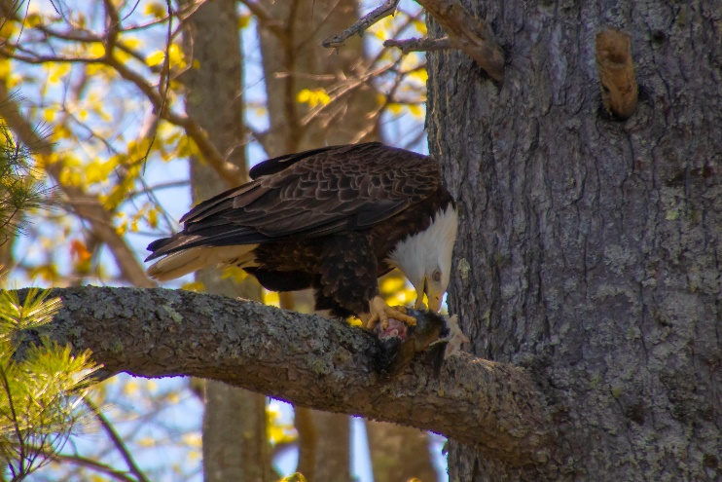Off the eagle flew heading south and carrying his prize about a short foot above the water. He headed for Snake Point, landing on a low tree branch along the shore about 100 feet east of the house on the Point.

We paddled our kayaks towards the area where he landed and spotted him up on a hefty branch. The lake waves were moderate as we drifted towards the eagle and his prey. Raising the camera, I began snapping images while drifting his way.

He obviously knew he had on-lookers but kept on obviously enjoying his majestic catch and watching us. Quietly we left him to enjoy his feast.

As it is said, when kayaking, never leave your camera in your cabin…

And for the photos, click on the [The dinner - May, 2018](https://photos.app.goo.gl/9jgIQRT9Nphn6qta2).